**AWS CLOUD COMPUTING**

**Practical no.4**

**AIM:** *Create Lambda Function in python to return JSON output as result .*

## **Step 1. Select a region**

One of the most important steps is to select the desired AWS region. This can be done from the top navigation bar of the AWS Console.

## **Step 2.** Navigate to the Lambda Function Console.

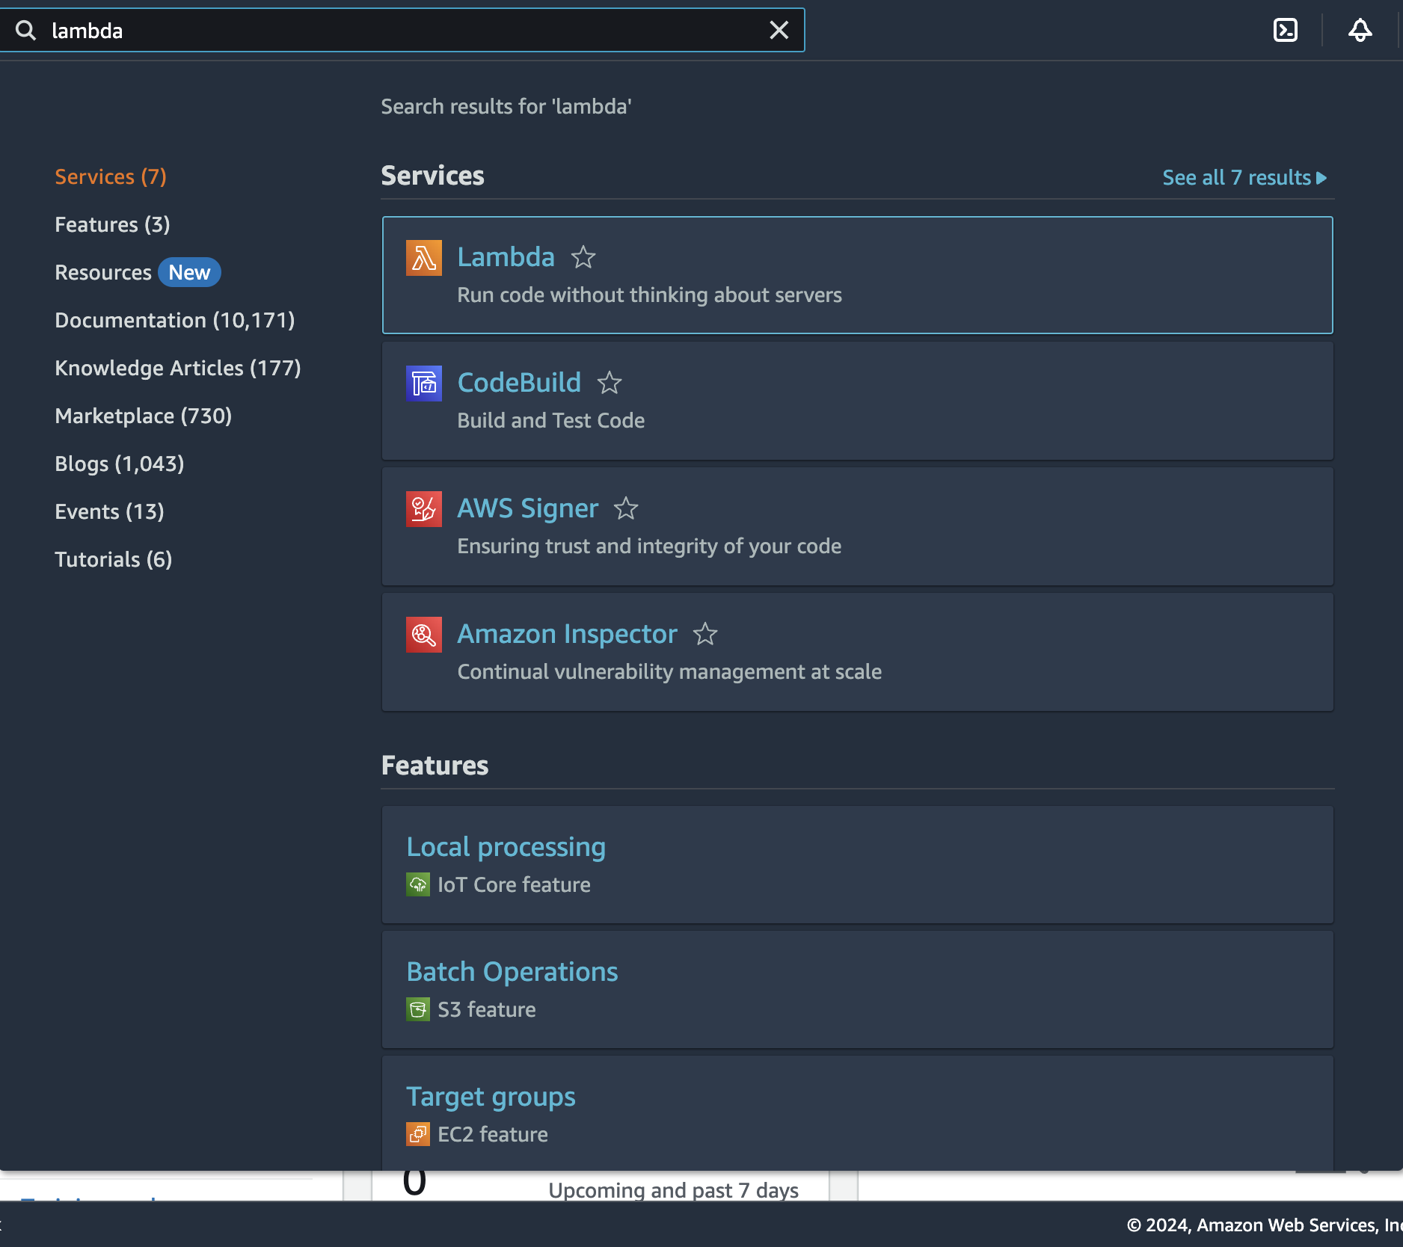

## **Step 3.** Click on the create function button to create a lambda function.

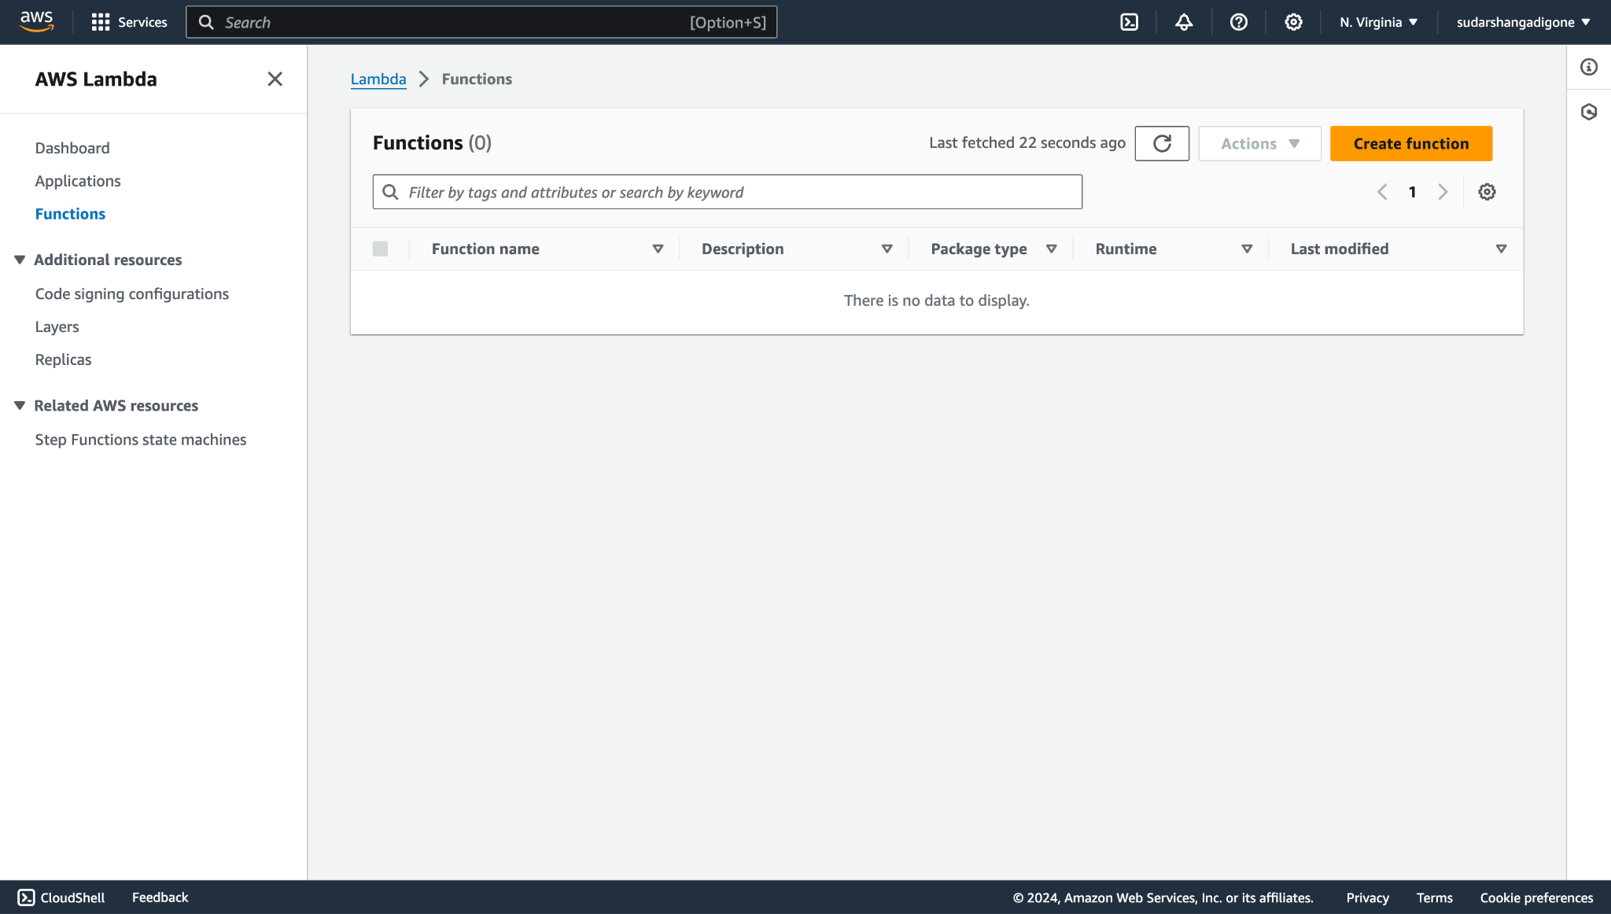

## **Step 4.** Enter a function name and proceed to create a function.

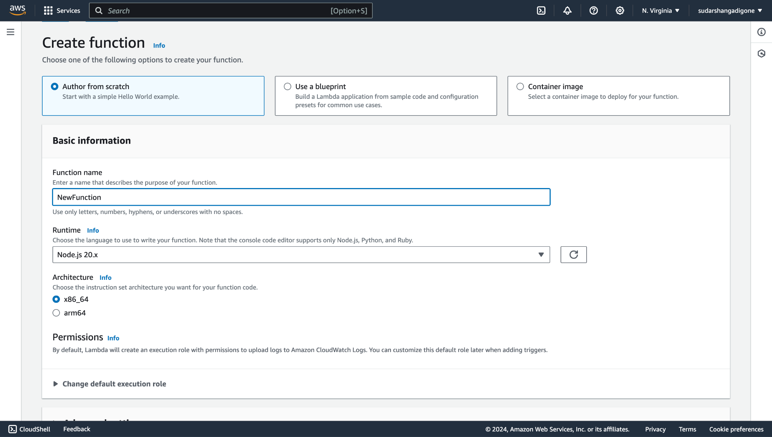

## **Step 5.** Hence, we have successfully created a lambda function.

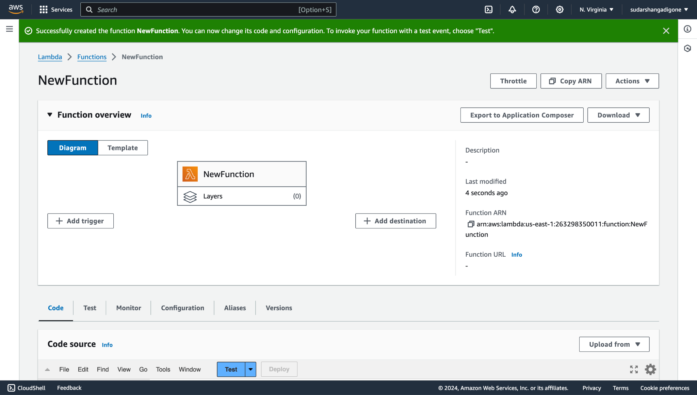

## 

## 

## 

## 

## 

## 

## 

## 

## 

## 

## 

## 

## **Step 6.** In Code Source enter the following code and click on test. The following output will be obtained.

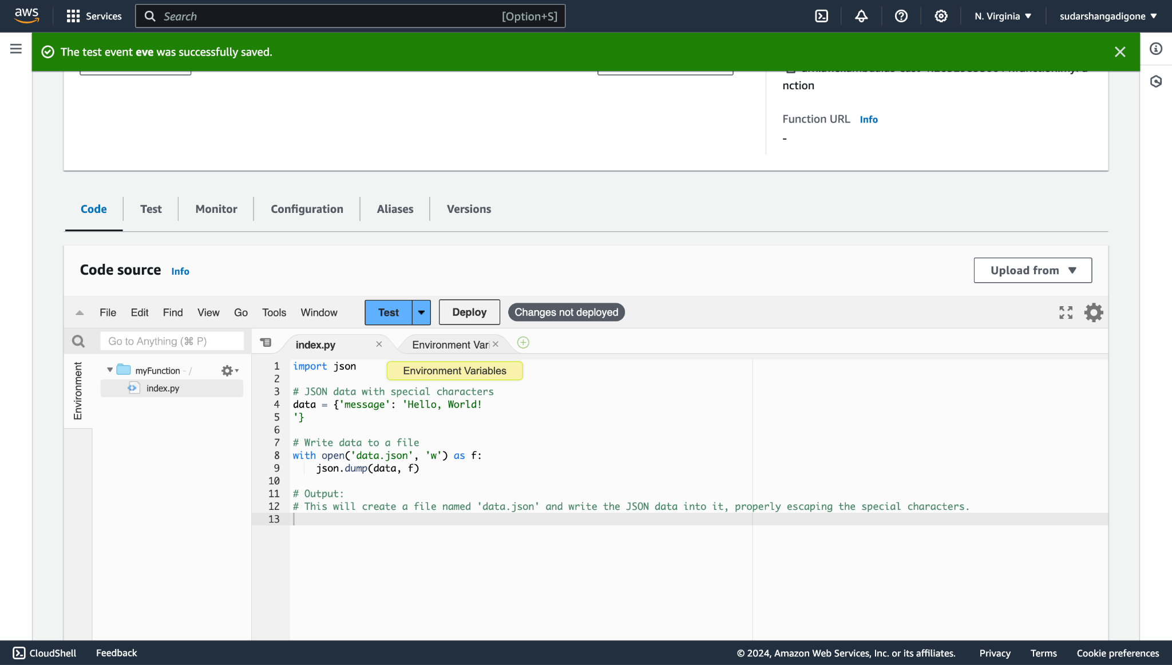

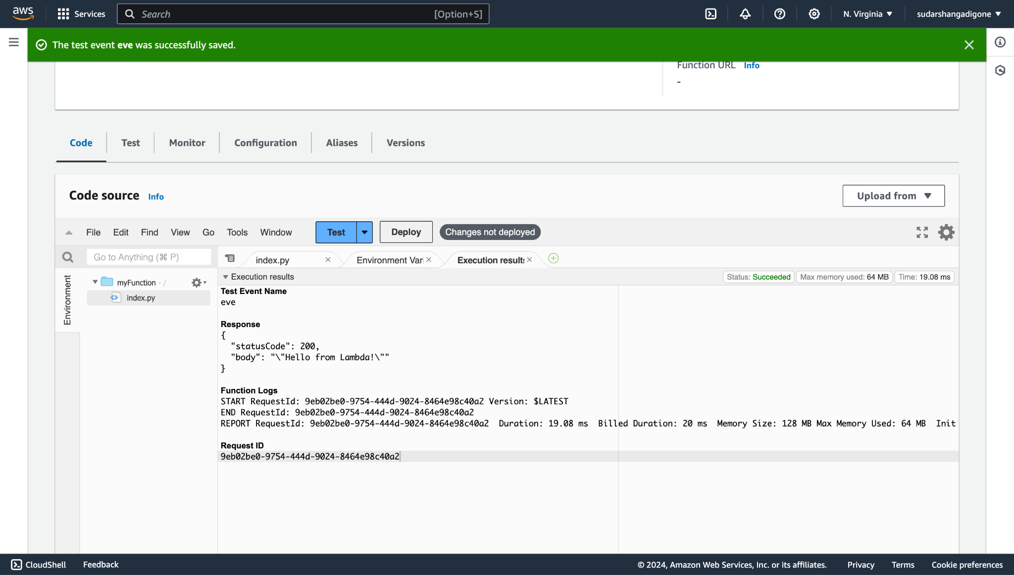

**CONCLUSION:**

Thus, we have successfully created Lambda Function in python to return JSON output as result.